**Product Dissection for *Flipkart***

**Step 1: Choose a Leading Platform**

Select a leading platform of your choice, which could span various domains such as social media, e-commerce, finance, or any other industry. This choice will form the foundation of your exploration into its schema design.

**Step 2: Research:**

Thoroughly research the platform you have selected. Investigate its core features, functionalities, and user interactions. Identify the top features that define its user experience and contribute significantly to its popularity.

**Step 3: Product Dissection and Real World Problems solved by the platform**

In this step, you will meticulously analyse the platform's standout features and how they provide innovative solutions to real-world challenges. By identifying key functionalities that resonate with users, you'll unravel how the platform effectively addresses problems and enhances user experiences. This dissection will serve as the foundation for understanding how the schema design aligns with the platform's core objectives.

**Step 4: Case Study on the real world problems and approach to solving them**

In this pivotal step, you will expand on the real-world challenges uncovered in Step 3 through a comprehensive case study. Delve into specific instances where users encountered difficulties and showcase how the platform's unique features provided effective solutions. By dissecting the approach taken by the platform to overcome these challenges, you'll gain a deeper appreciation for the platform's user-centric design philosophy and how it shapes the schema design.

**Step 5: Schema Design Based on Top Features**

Based on the features you have identified, craft a schema design that reflects the platform's data structure. Focus on the key entities, attributes, and relationships that underpin the chosen features. Your schema should capture the essence of how the platform organises and utilises its data.

**Step 6: Rationale Behind the Design**

While creating the schema design, consider the rationale behind the platform's choices. Reflect on why certain entities and relationships were chosen and how they align with the platform's goals. This will help you understand the strategic decisions driving the schema's architecture.

**Step 7: Create an ER Diagram**

Utilise tools like the Miro platform or similar applications to create an illustrative Entity-Relationship (ER) diagram. This diagram should vividly depict the entities, attributes, and relationships present within your schema design. The ER diagram will serve as a visual representation of your insights.

**Step 8: Presentation of Findings**

Present your findings in a clear and concise manner. Showcase your understanding of how the schema design impacts the platform's functionality and user experience. Explain how your chosen features are integrated into the schema and how the schema's structure supports the platform's objectives.



**Product Dissection for *Flipkart* :   
  
Company Overview:**

Flipkart, founded in 2007 by Sachin Bansal and Binny Bansal, has revolutionised the e-commerce landscape in India. Acquired by Walmart, Flipkart has become a dominant force in the Indian online retail market, known for its wide range of products, seamless shopping experience, and innovative features. With a focus on providing convenient and affordable shopping solutions, Flipkart has garnered millions of loyal customers, making it one of the leading e-commerce platforms in India.

**Product Dissection and Real-World Problems Solved by Flipkart:**

Flipkart, a pioneering e-commerce platform, has effectively addressed real-world challenges through its innovative product offerings. With a focus on convenience, affordability, and customer satisfaction, Flipkart has transformed the way people shop online in India. By offering a diverse range of products, secure payment options, and reliable delivery services, Flipkart provides practical solutions to the evolving needs of its customers.

Flipkart's intuitive user interface and personalized shopping experience have revolutionised online shopping in India. By providing detailed product descriptions, customer reviews, and product recommendations, Flipkart helps users make informed purchasing decisions, solving the problem of uncertainty and hesitation in online shopping. Additionally, Flipkart's hassle-free return and refund policies reassure customers, fostering trust and loyalty in the platform.

In conclusion, Flipkart's product design has successfully tackled real-world problems by creating a platform that prioritises customer convenience, affordability, and trust. Through its diverse product offerings, user-friendly interface, and reliable services, Flipkart has redefined the e-commerce experience in India, making shopping online more accessible and enjoyable for millions of users.

**Case Study: Real-World Problems and Flipkart's Innovative Solutions**

Flipkart, a trailblazer in the Indian e-commerce industry, has not only transformed the way people shop online but has also addressed significant real-world challenges through its innovative features. By understanding customer needs and leveraging technology, Flipkart has emerged as a customer-centric platform that prioritises convenience, affordability, and reliability.

**Problem 1: Limited Access to Products in Remote Areas**

**Real-World Challenge:**

Residents of remote areas often face challenges accessing a wide range of products due to limited availability and logistical constraints.

**Flipkart's Solution:**

Flipkart recognized the need to democratise access to products across India. By leveraging its extensive logistics network and partnerships with sellers, Flipkart ensures that customers from remote areas have access to a diverse range of products. The platform's robust delivery infrastructure reaches even the most remote locations, solving the problem of limited access and expanding the reach of e-commerce in India.

**Problem 2: Trust and Reliability in Online Transactions**

**Real-World Challenge:**

Many consumers hesitate to shop online due to concerns about the security of transactions and the authenticity of products.

**Flipkart's Solution:**

Flipkart prioritises trust and reliability in every transaction. By implementing secure payment gateways and stringent quality control measures, Flipkart ensures that customers can shop with confidence. The platform also offers genuine products from trusted sellers, backed by comprehensive warranty and   
return policies. Through these initiatives, Flipkart addresses the challenge of trust in online transactions, earning the confidence of millions of customers across India.

**Problem 3: Price Sensitivity and Affordability**

**Real-World Challenge:**

Price sensitivity is a significant factor influencing purchasing decisions, especially in a price-conscious market like India.

**Flipkart's Solution:**

Flipkart understands the importance of affordability for its customers. By offering competitive prices, frequent discounts, and exclusive deals, Flipkart makes online shopping accessible to a wide range of consumers. The platform's commitment to affordability ensures that customers can find value for money across various product categories, addressing the challenge of price sensitivity and enhancing the overall shopping experience.

**Problem 4: Product Discovery and Decision-Making**

**Real-World Challenge:**

With a vast array of products available online, customers often struggle to discover relevant items and make informed purchasing decisions.

**Flipkart's Solution:**

Flipkart simplifies the product discovery process through intuitive search filters, detailed product descriptions, and customer reviews. The platform's recommendation algorithms analyze user preferences and browsing history to suggest personalized product recommendations, helping customers discover new items tailored to their interests. By empowering customers with relevant information and insights, Flipkart addresses the challenge of product discovery, making shopping online more engaging and enjoyable.

**Conclusion:**

Flipkart's journey from a startup to a market leader is a testament to its ability to understand customer needs and provide innovative solutions. By prioritizing convenience, affordability, and reliability, Flipkart has reshaped the e-commerce landscape in India, making online shopping more accessible and enjoyable for millions of users. This case study highlights how Flipkart's customer-centric approach and continuous innovation have established it as a trusted brand in the Indian market, setting new standards for excellence in e-commerce.

**Top Features of Flipkart:**

1. **User Profiles:-** Flipkart allows users to create personalized profiles, providing insights into their shopping preferences and order history.
2. **Product Listings:** A core feature of Flipkart is the extensive catalog of products across various categories, including electronics, fashion, home essentials, and more.
3. **Search and Filters:** Users can easily search for products and apply filters to narrow down their options based on price, brand, ratings, and other criteria.
4. **Secure Payment Options:** Flipkart offers multiple secure payment options, including credit/debit cards, net banking, wallets, and cash on delivery, ensuring a seamless checkout experience.
5. **Customer Reviews:** Users can read and write reviews for products, sharing their experiences and insights to help other shoppers make informed decisions.
6. **Order Tracking:** Flipkart provides real-time tracking updates for orders, allowing users to monitor the status of their deliveries and estimated delivery dates.

**Schema Description:**

The schema for Flipkart comprises various entities that represent different aspects of the e-commerce platform. These entities include Shipment, Customer, Order, Payment, Cart, Product, Order_Item, Wishlist, and Category. Each entity has specific attributes that describe its properties and relationships with other entities.

**1. Shipment :** Manages shipping details for orders.

* **shipment_id (Primary Key):** A unique identifier for each shipment.
* **shipment_date:** The date when the shipment was made.
* **address:** The shipping address for the shipment.
* **city:** The city of the shipping address.
* **state:** The state of the shipping address.
* **country:** The country of the shipping address.
* **zip_code:** The zip code of the shipping address.
* **Customer_custom (Foreign Key):** References the customer who placed the order.

**2. Customer :** Stores user information for orders and interactions.

* **customer_id (Primary Key):** A unique identifier for each customer.
* **first_name:** The first name of the customer.
* **last_name:** The last name of the customer.
* **email:** The email address of the customer for communication.
* **password:** The password associated with the customer's account.
* **address:** The shipping address of the customer.
* **phone_number:** The phone number of the customer.

**3. Order :**  Tracks purchase details and associated products**.**

* **order_id (Primary Key):** A unique identifier for each order.
* **order_date:** The date and time when the order was placed.
* **total_price:** The total price of the order.
* **Customer_custo (Foreign Key):** References the customer who placed the order.
* **Payment_payme (Foreign Key):** References the payment method used for the order.
* **Shipment_shipm (Foreign Key):** References the shipment associated with the order.

**4.** **Payment :**  Manages transaction details for orders.

* **payment_id (Primary Key):** A unique identifier for each payment.
* **payment_date:** The date when the payment was made.
* **payment_method:** The method used for payment.
* **amount:** The amount paid for the order.
* **Customer_custome (Foreign Key):** References the customer who made the payment.

**5. Cart :**  Stores selected items for potential purchase.

* **cart_id (Primary Key):** A unique identifier for each cart.
* **quantity:** The quantity of items in the cart.
* **Customer_customer_id (Primary Key, Foreign Key):** References the customer who owns the cart.
* **Product_product_id (Foreign Key):** References the product added to the cart.

**6. Product :**  Represents items available for sale.

* **product_id (Primary Key):** A unique identifier for each product.
* **SKU:** The stock keeping unit of the product.
* **description:** A description of the product.
* **price:** The price of the product.
* **stock:** The available stock quantity of the product.
* **Category_catego (Foreign Key):** References the category to which the product belongs.

**7. Order_Item :** Tracks individual items within orders.

* **order_item_id (Primary Key):** A unique identifier for each order item.
* **quantity:** The quantity of the product in the order item.
* **price:** The price of the product in the order item.
* **Product_prod (Foreign Key):** References the product included in the order item.
* **Order_order_i (Primary Key, Foreign Key):** References the order to which the order item belongs.

**8. Wishlist :** Stores desired products for future purchase.

* **wishlist_id (Primary Key):** A unique identifier for each wishlist.
* **Customer_customer_id (Primary Key, Foreign Key):** References the customer who owns the wishlist.
* **Product_product_id (Foreign Key):** References the product added to the wishlist.

**9. Category :** Classifies products into distinct groups.

* **category_id (Primary Key):** A unique identifier for each category.
* **name:** The name of the category.

**Relationships are :**

* **Customers and Orders:**

The relationship between customers and orders allows Flipkart to track individual customer purchases and manage order processing efficiently. It enables customers to place orders for products they intend to purchase, which is fundamental to an e-commerce platform.

* **Products and Categories:**

Organizing products into categories helps users navigate through Flipkart's vast inventory more easily. By categorizing products, customers can quickly find items of interest, leading to improved user experience and increased sales.

* **Customers and Payments:**

The relationship between customers and payments facilitates secure transactions and ensures a smooth checkout process. It allows Flipkart to process payments for orders made by customers using various payment methods, enhancing convenience and trust.

* **Customers and Wishlists:**

Wishlists provide customers with a way to save products they are interested in purchasing later. This relationship enables customers to curate a list of desired items, enhancing engagement and encouraging repeat visits to the platform.

* **Customers and Carts:**

The association between customers and carts enables users to add products to their carts before completing the purchase. This feature allows customers to review and modify their selections, providing flexibility and convenience during the shopping process.

* **Products and Orders:**

The link between products and orders is crucial for inventory management and order fulfillment. It allows Flipkart to track which products are included in each order, update stock levels accordingly, and ensure timely delivery to customers.

* **Customers and Reviews:**

Customer reviews play a vital role in informing purchase decisions and building trust among users. By allowing customers to leave reviews for products they have purchased, Flipkart fosters transparency and encourages user-generated content, which can influence buying behavior.

**ER Diagram :**The ER diagram for Flipkart depicts relationships among entities. Customers place orders, each comprising multiple items, associated with payments and shipments. Customers also maintain wishlists and carts, and provide reviews. Products are categorized, and each belongs to an order item. Payments are made by customers and associated with orders. Wishlists store desired products, while carts contain selected items. Reviews are left by customers for products. This ER diagram captures the core functionalities and interactions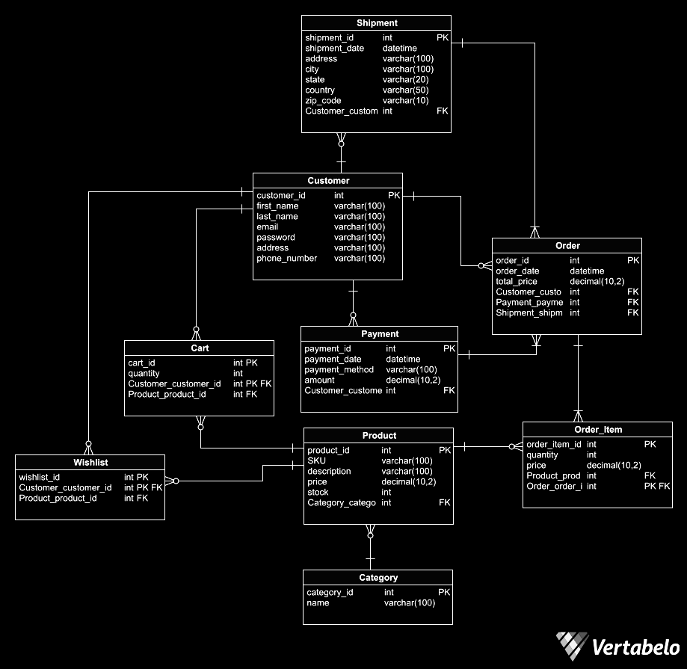within Flipkart's e-commerce platform, facilitating efficient order processing, inventory management, and customer engagement.

**Conclusion:**

In this case study, we explored the schema design of Flipkart, an influential e-commerce platform. Flipkart's schema orchestrates seamless interactions between customers, orders, products, payments, and more. By intricately structuring entities and relationships, Flipkart facilitates efficient order processing, inventory management, and user engagement. The schema reflects Flipkart's commitment to providing a dynamic and customer-centric online shopping experience. By comprehensively understanding Flipkart's schema, we gain insight into how the platform manages user interactions, product listings, and transactions, contributing to its prominence in the competitive e-commerce landscape.